Morristown Student Council & PTO Sponsored Family Fun Festival
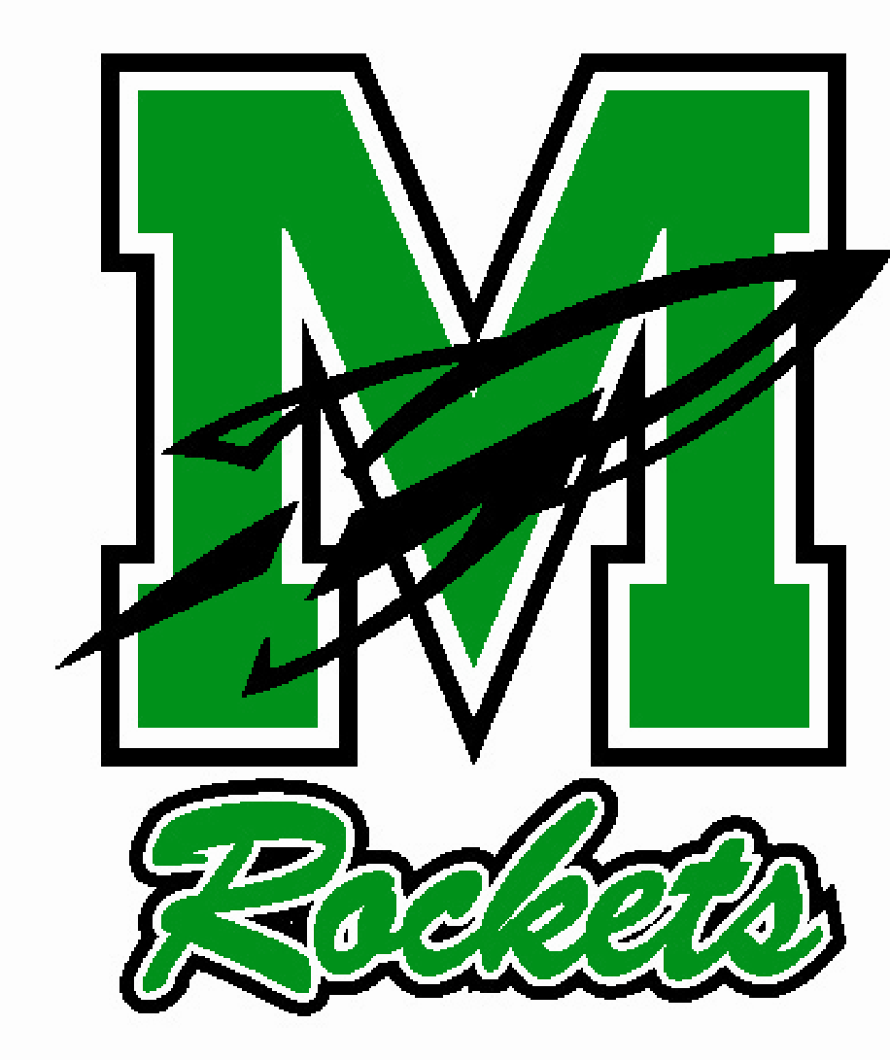

Join us for a BBQ-style lunch outside on Thursday, June 9th (Rain Date: Friday, June 10th). The cafeteria will serve hot dogs, hamburgers, barbecue chicken, pasta salad, chips, and drinks. You are welcome to bring your own lunch and a blanket to spread out on the lawn to watch and join in on the games!
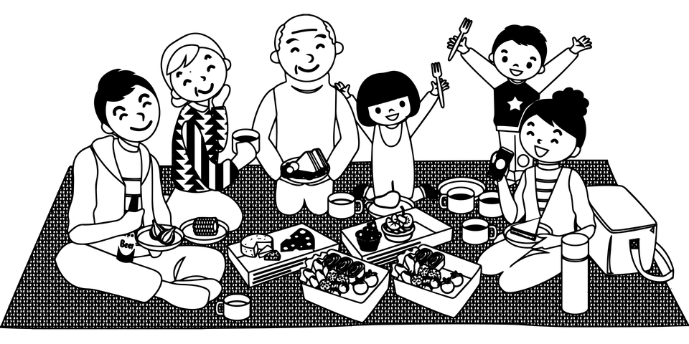

***************************************************************************
Please complete the reservation form below and return it to your child’s teacher or the Main Office by Wednesday, June 1st. Student lunches are free. The price of an adult lunch is $6.00 each. If you plan to buy a picnic lunch, please indicate how many you will purchase, and return the bottom portion of this page. You do not need to return the sheet if you are bringing lunch. To avoid confusion, there is no pre-sale for adult lunches. Please pay on the day of the picnic.

____ Number of adult lunches I will be purchasing for $6.00 each.

Student Name:
Teacher/Grade:

